Circuit Analysis (Lab10)

Experiment 9: Verification of Thevenin’s Theorem

Name: Muhammad Abdullah Registration No:2025- CE- 54
Date--- Grade and Signature: ……………………
CLO2 CLO3 | Use with identification the circuit components, breadboards, multimeter, power supplies, signal generators, and oscilloscopes. Make measurements in their own constructed electric circuits.
Psychomotor/Affective | Level1  (1) | Level2 (2-3) | Level3 (4-5) | Level4 (6-7)
Report Marks (3)
 | Total marks (10)

Objective
The objective of this lab is verify Thevenin’s theorem and to find the full load current.

Apparatus Required
Sr. no | Apparatus | Range | Quantity
1 | Regulated Power Supply | Standard | 1
2 | Signal Generator | Standard | 1
3 | Oscilloscope | Standard | 1
4 | Digital Multimeter | Standard | 1
5 | Breadboard & Wires | Standard | As Required
6 | Resistors | 1k, 330 ohms | 1,3
7 | Potentiometer | Standard | 1

Description

Statement:
Any linear bilateral, active two terminal network can be replaced by an equivalent voltage source (VTH). Thevenin’s voltage or V OC in series with looking pack resistance RTH.

Precautions:
- Voltage control knob of RPS should be kept at minimum position.
- Current control knob of RPS should be kept at maximum position

Procedure:
- Connections are given as per the circuit diagram.
- Set a particular value of voltage using RPS and note down the corresponding ammeter readings. To find VTH 3. Remove the load resistance and measure the open circuit voltage using multimeter (VTH). To find RTH
- To find the Thevenin’s resistance, remove the RPS and short circuit it and find the RTH using multimeter.
- Give the connections for equivalent circuit and set VTH and RTH and note the corresponding ammeter reading. 6. Verify Thevenins theorem.

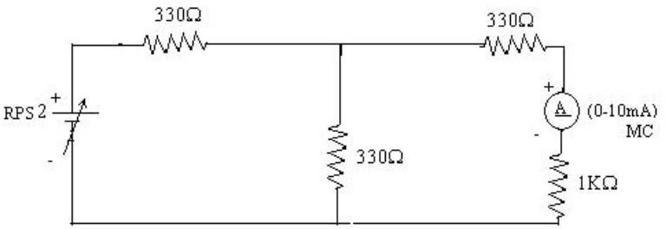
Circuit - 1: To find load current

To find VTH
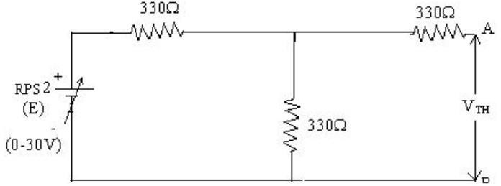

To find RTH
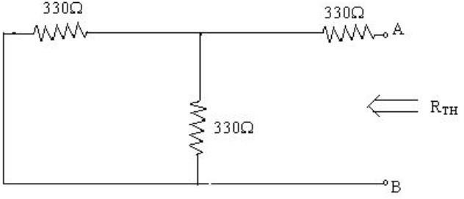

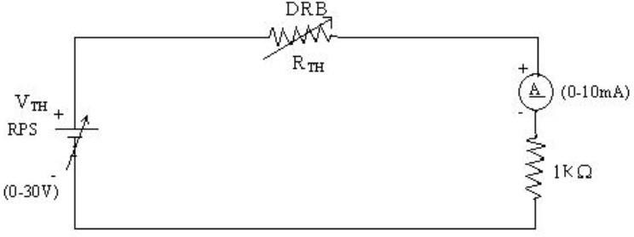
Thevenin’s Equivalent circuit:

Thevenin Practical Values

 | E(V) | VTH(V) | RTH(ohms) | IL (mA)
 |  |  |  | Circuit - I | Equivalent Circuit
Values | 10 | 5 | 495 | 3.34 | 3.34

Post Lab Questions

1. What is Thevenin’s Theorem?
Thevenin’s Theorem states that any linear electrical network can be replaced by an equivalent circuit.
The equivalent circuit consists of a single voltage source called Thevenin voltage.
It also contains a series resistance called Thevenin resistance.
This theorem simplifies the analysis of complex circuits.
It is mainly used for analyzing load current and voltage easily.

2. What are the applications of Thevenin’s Theorem?
Thevenin’s Theorem is used to simplify complex electrical circuits.
It helps in finding current and voltage across a load resistor.
It is widely used in circuit analysis and network design.
The theorem is useful in power system and electronic circuit calculations.
It also helps in studying the effect of changing load resistance.

3. What are the theoretical and practical limitations of Thevenin’s Theorem?
Thevenin’s Theorem is applicable only to linear and bilateral circuits.
It cannot be directly used for non-linear components like diodes and transistors.
The theorem is not suitable for circuits containing only dependent sources without modification.
Finding Thevenin resistance in complex circuits can sometimes be difficult.
In practical circuits, measurement errors and component tolerances may affect accuracy.

